Prebbleton Community Association Inc
Tues 15th August 2023 at 7.00pm at Prebbleton Community Cottage

Present: Graeme Gemmill, Graham Carpenter, Averil Carpenter, Dave Martin, Alastair Joyce, Cr Malcolm Lyall, Angela Hart, Jane Elms
Apologies: Ange Jones, Geoff Gilfedder and Natalie McLean
Minutes from the last meeting: Accepted with 2 corrections, moved Angela H, seconded Alastair Joyce.
Matters arising:
Averil had email conversations with Johnathan Crawford and Joelle from Reserves at SDC on the topic of suitable plants for the beds by the pedestrian crossing and the entries to Prebbleton. Creeping thyme was planted at the crossing but hasn’t done very well. The crossing beds have now been covered in bark but hopefully a more suitable plant will be found and installed soon. There was discussion on the dangers of the crossing and distraction or visibility issues caused by plants. However a colourful but low growing, hardy plant would surely highlight the crossing. Careless motorists happen regardless.
Replacement signs for the entry to Selwyn District are already planned, but will take time.
Red paint on the road to highlight the pedestrian crossing has already been suggested to SDC by Malcolm.
PCA Correspondence 18th July to 13th August 2023

SDC apology from Malcolm Lyall, cannot attend meeting on 18th as positive for Covid.

Ange Jones/Alastair/Nicola Duke eCan/Angela H re limited consent notification

Averil re Selwyn Awards

Dave Martin re PL

Ange J /Alastair re Selwyn Times Matariki Event coverage

SDC re submission to annual plan

Averil re location of display board for Pocket Park area.

Mikayla Cotton SDC re locked lockers at cottage

Averil/Jonathan Crawford SDC re signage and maintenance of roadside gardens on Springs

Angela H to Sarah Shallcrass, Charities Services to withdraw application.

Angela H to Thomas Cockburn, Management Accountant SDC re accountability for discretionary fund. There is none.

Averil with photos of Springston noticeboard

Angela H to SDC OIA request re Cell Tower fund. See below.

Hello there,

At last year’s AGM for the Prebbleton Community Association, the audience was told about a significant amount of funds donated for the benefit of Prebbleton Community and held by Selwyn District Council. This was referred to as the Cell Tower fund. For some years the Prebbleton Community Association received accounting statements from SDC keeping track of these funds, but there has been no information provided more recently.

Can you please provide details of the expenditure of these monies, what the funding criteria are and how to apply, I could find nothing on the SDC website.

Regards

Angela Hart

SDC response:

On Tue, 1 Aug 2023 at 16:10, Thomas Cockburn <Thomas.Cockburn@selwyn.govt.nz> wrote:
Hi Angela

The fund had an expiry date of 30 June 2021, based upon the special fund review policy January 2016. From the expiry of the fund, the remaining balance was transferred out.
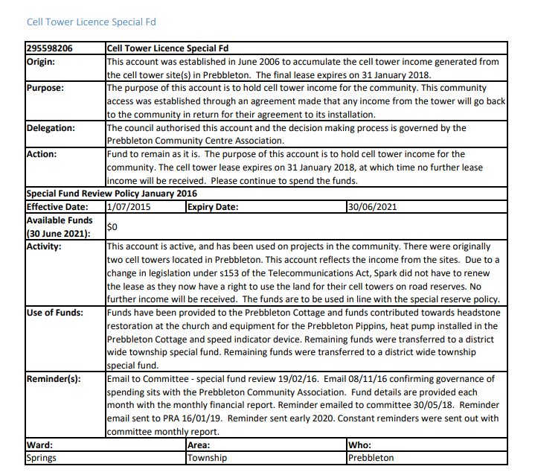
Below was the report on the special fund

Cheers Thomas

Thank you Thomas,
can you tell me how much money was transferred to the district wide township special fund?
Regards
Angela

Hi Angela

There was $73,021 in the fund that was transferred over.

Cheers Thomas

thanks Thomas,
is this District Wide Township Special Fund one that is available to residents groups to apply for or is it solely available to SDC?

Thanks for your help
Regards
Angela

Hi Angela
I believe it was to be used by SDC for the small projects that weren’t budgeted in the annual plan or long term plan. I don’t believe that resident groups can apply for the fund.

Cheers Thomas

Alastair
I did a search through the PCA emails to try to find something regarding reminders to spend all the cell tower funds or lose them. Could find nothing however the following email would suggest we should still have control of these funds as per the highlighted sentence. I believe there is a good reason to challenge SDC that this money should still be dedicated to Prebbleton as per the original agreement that these funds were to be in exchange for the residents of Prebbleton agreeing to the cell towers being erected.. We need to talk about this further maybe at this months meeting if we are not overloaded with other items
Cheers
Alastair

---------- Forwarded message ---------
From: committees <committees@selwyn.govt.nz>
Date: Thu, Mar 5, 2020 at 4:16 PM
Subject: Prebbleton Community Association
To: Prebbleton Community Assn Inc <prebbleton.cai@selwyn.govt.nz>, prebbletoncommunityassn@gmail.com <prebbletoncommunityassn@gmail.com>
Cc: Cr Debra Hasson <CrDebra.Hasson@selwyn.govt.nz>, Cr Malcolm Lyall <CrMalcolm.Lyall@selwyn.govt.nz>, Cr Grant Miller <CrGrant.Miller@selwyn.govt.nz>

Dear Committee

In addition to your special reserve funds balances being reported on the bottom of your monthly financial reports the below table summaries your current funds.

Your fund expires on the 30 June 2020. Any funds not spent or committed by 30 June 2020 to be spent as part of the annual plan in the 2020/21 financial year will be transferred to your operating account.

295598206 | Cell Tower Licence Special Fund
Origin: | This account was established in June 2006 to accumulate the cell tower income generated from the cell tower site(s) in Prebbleton. The final lease expires on 31 January 2018.
Purpose: | The purpose of this account is to hold cell tower income for the community. This community access was established through an agreement made that any income from the tower will go back to the community in return for their agreement to its installation.
Delegation: | The council authorised this account and the decision making process is governed by the Prebbleton Community Centre Association.
Action: | Fund to remain as it is. The purpose of this account is to hold cell tower income for the community. The cell tower lease expires on 31 January 2018, at which time no further lease income will be received. Please continue to spend the funds.
Special Fund Review Policy January 2016
Effective Date: | 01/07/2015 | Expiry Date: | 30/06/2020
Available Funds  (30 June 2019): | $71,247
Activity: | This account is active, and has been used on projects in the community. There were originally two cell towers located in Prebbleton. This account reflects the income from the sites. Due to a change in legislation under s153 of the Telecommunications Act,
Use of Funds: | Funds have been provided to the Prebbleton Cottage and funds contributed towards headstone restoration at the church and equipment for the Prebbleton Pippins, heat pump installed in the Prebbleton Cottage and speed indicator device.
Reminder(s): | Email to Committee - special fund review 19/02/16. Email 08/11/16 confirming governance of spending sits with the Prebbleton Community Association. Fund details are provided each month with the monthly financial report. Reminder emailed to committee 30/05/18. Reminder email sent to PRA 16/01/19. Email reminder sent early 2020.
Ward: | Area: | Who:
Springs | Township | Prebbleton

Year | Opening Balance | Interest Accrued | Income | Expenditure | Closing balance
2015 | $70,907 | $1,894 | $8,024 | $23,578 | $57,248
2016 | $57,248 | $1,833 | $8,024 | $314 | $66,791
2017 | $66,791 | $2,096 | $8,024 | $1,843 | $75,068
2018 | $75,068 | $2,128 | $0 | $8,239 | $68,958
2019 | $68,958 | $2,289 | $0 | $0 | $71,247

Cheers Thomas

Thomas Cockburn
Assistant Accountant

Claire Trent re Prebbleton Plunket coffee group promo in PL

Hilary Armstrong Blue Print invoice for PL

Janita Clark re ballroom dance classes piece for PL

Averil/Joelle SDC reserves officer re plantings for roadside beds- creeping thyme!

MBIE re registration for incorporated societies starting in October

Ange J please add “Spring markets” to agenda

Cooper Cherry/Angela H re pantry he has made asking if it can be located close to the cottage. Suggested Church land might be more straight forward. He will send photos and dimensions when it is finished and then we will be able to take the request further. He will have a builder fix it to the ground and ensure it is weather proof and undertakes to keep it clean and tidy himself.

Garden City Cavy club National Guinea pig show poster for PL

CRA
Nicola Grigg
St Albans News

Angela H moved that the correspondence be accepted, seconded Graham, passed.

Matters arising from Correspondence:

The Cell Tower fund. Malcolm considers that the email sent to PCA stating that the monies would be transferred to our operating account on the expiry date meant that the monies would go to the SDC operating account.
However, he has checked and understands that the money remains in the township special fund and could still be spent on Prebbleton if suitable projects were proposed.
Alastair moved that we write to Thomas Cockburn asking for permanent stop warning signs to be installed at the Longstaffs/Trices Road intersection on both sides, using this fund, seconded Graham, passed.
There was discussion on the topic of security cameras. Angela H suggested a camera overlooking the pedestrian crossing might improve safety and Malcolm explained about Darfield’s system and suggested a similar one for Prebbleton.
Dave moved that we write to ask for community security cameras to be installed at key points around Prebbleton, probably main roads and possibly the pedestrian crossing, networked and with the feed accessible to the police. A similar network to that in Darfield which has proven very effective in catching criminals and in deterring them, seconded Averil, passed.
Malcolm will support both of these proposals and we are agreed that they would be a good use of the Cell Tower Fund monies.

Copper Cherry’s initiative with a Community Pantry was well received and we await photos and dimensions of the Pantry.
Financial Report:
Summary for the period from 14-07-23 to 11-08-23

Receipts
Donations/Grants 50.00 (Matariki Balloons/Donations)
Interest received 17.13
Total — Receipts 67.13

Less: Payments
Advertising /promotion 575.00 (newsletter)
Community Event 85.92 (Matariki payments less receipts)
Miscellaneous Costs 5.99 (card)
Total — Payments 666.91

Net increase (decrease) in cash held (599.78)

Cash at the beginning of the period 10,340.63

Cash at the end of the period 9,740.85 - Westpac Account $9665.85
Cash Account $75.00

…………………………………………………………………………………………………………………………………………………………….

Accounts for Approval and Payment : Selwyn Print, (BluePrint) August PL $575.00

Alastair moved that the financial report and the account for payment be accepted and approved, seconded Jane, passed.

Newsletter update: Content for September is coming together, there will be a piece on Selwyn Gets Ready, Civil Defence, one about the Barbers shop, something about critters which are pests here but treasured in their countries of origin. Report accepted, moved Dave, seconded Angela, passed.
Cottage update: There was an issue with a locked locker but it went away.
Graham and Averil have weeded and tidied the Cottage garden and would like some donated plants to fill gaps. A trailer load of mushroom compost will be purchased for this garden and when receipts and a bank account number are provided, Malcom will reimburse the $40 from his discretionary account. Report accepted moved Graham, seconded Alastair.
SDC Prebbleton update: Malcolm told us there is a lot of consultation coming; on the long term plan, a representation review( number of councillors, ward system, voting system), and an alcohol plan ( sale and supply rules, licensing of bars etc).
Malcolm will ask the SDC comms team about getting information to the PCA email address which currently gets nothing from SDC.
The Trents/Hamptons/Shands roundabouts are fully funded and going to happen but there is a delay because landowners are unhappy.
The Springs/Hamptons roundabout funding will be shared with Waka Kotahi but is waiting on funding confirmation from Waka Kotahi.
The District Plan is up for approval tomorrow afternoon and will be made public on the 19th.
SDC update accepted with thanks, moved Malcolm, seconded Averil.
Pocket Park update: Some of us met with Shannon at the Pocket Park to see what she has in mind.
Graeme moved that the PCA accept the moving of the notice/display board on to the pocket park section, seconded Angela, passed but with Jane and Averil against. Malcolm has offered to install a floodlight which will be connected to the shops power supply.
Rules / Constitution update:
Jane has it in hand and will email something out to everyone soon.
General:
Alastair has put in a submission to GLG on the proposed Community Centre. Malcolm suggested the Tai Tapu facility is a good example of a versatile building, however we are aware of issues the regular users have, sharing facilities isn’t necessarily easy. There was discussion on possible sites with no conclusion reached.
About 1000 new residential consents have been approved, so that could be another 3,000 people.
Markets: Ange J has had stall holders asking when the next market will be. As previously decided, the next one will be the Christmas Carol event.
Next meeting – September 19th, 7pm.
Meeting closed at 8:55pm.

